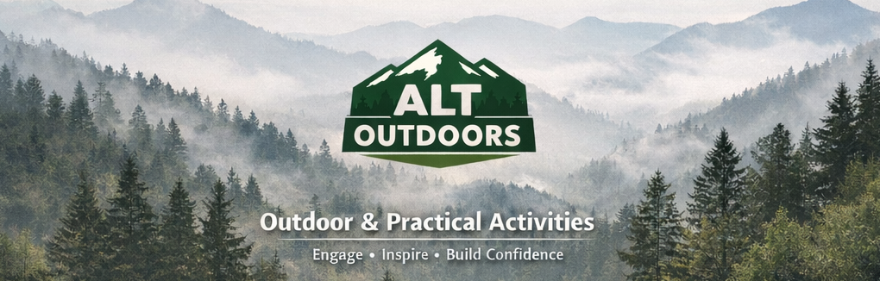

Programme Overview – Alternative Provision

Provider Overview
Provider Name: Alt Outdoors Ltd
Director: William Gladwin-Nelson
Legal Status: Limited Company
Operating Model: Independent Provider
Alt Outdoors Ltd delivers high-quality, bespoke alternative provision for children and young people who are unable to fully access mainstream education. The provision is designed for learners who require a flexible, relational and personalised approach to support engagement, emotional wellbeing, confidence and positive educational outcomes.
Provision is led by William Gladwin-Nelson, ensuring consistency, accountability and high professional standards across all placements. Alt Outdoors combines outdoor education, practical project learning, adventure activities and community engagement to create meaningful opportunities for personal, social and educational development.

Age Range & Learner Cohort
Alt Outdoors primarily supports learners from Key Stage 3 through to Post-16.
The provision supports young people who may experience SEMH needs, Autism Spectrum Condition (ASC), ADHD, anxiety, emotionally based school avoidance (EBSA), low confidence, social communication difficulties, behavioural needs, reintegration needs and preparation for adulthood needs.

Aims & Intended Outcomes
The core aim of Alt Outdoors is to support young people to re-engage with learning, develop confidence and resilience, improve emotional wellbeing and make meaningful progress towards educational, social and personal outcomes.
Provision is designed to support emotional regulation, confidence, resilience, engagement with education, social communication, independence, preparation for adulthood and progress towards EHCP outcomes where applicable.

Provision Model & Session Structure
Provision is flexible and responsive and may include 1:1 support, small-group provision, half-day and full-day sessions, short-term intervention placements and longer-term placements.

Curriculum & Activities
Provision may include outdoor education, bushcraft and woodland skills, mountain biking, orienteering and navigation, practical project-based learning, environmental projects, community engagement activities, life skills development and preparation for adulthood experiences.

Staffing, Experience & Professional Capacity
Alt Outdoors Ltd is led by William Gladwin-Nelson, a qualified teacher with over ten years of experience across mainstream, alternative provision and specialist SEND settings.
Qualifications and experience include Qualified Teacher Status (QTS), Pastoral Lead experience, Head of Outdoor Education experience, MIAS Level 2 Mountain Bike Leader, Level 3 Safeguarding and First Aid qualifications.

Safeguarding, Behaviour & SEND
Safeguarding is embedded throughout all aspects of provision and operates in accordance with Keeping Children Safe in Education (KCSIE), local safeguarding procedures and organisational safeguarding policies.
Provision includes enhanced DBS clearance, safeguarding training, comprehensive risk assessments and individual consideration of SEND and medical needs.

Partnership & Communication
Alt Outdoors works collaboratively with schools, local authorities, families and partner agencies through attendance reporting, progress reviews, placement updates and outcome monitoring.

Summary
Through outdoor education, adventure activities, practical project learning and community engagement, young people are supported to build confidence, improve emotional regulation, develop independence and make meaningful progress towards educational, social and personal outcomes.

