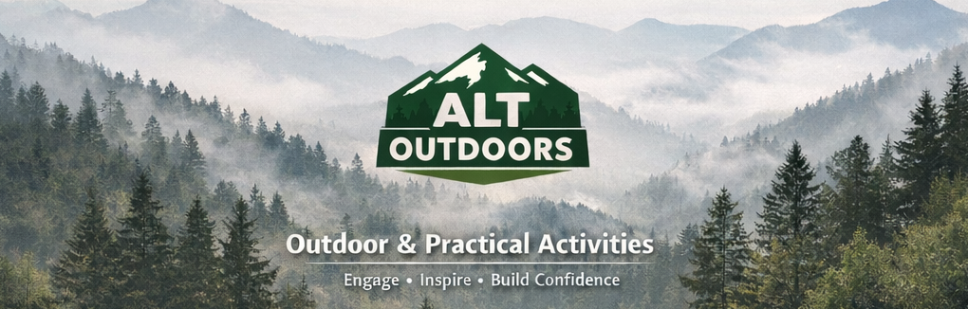
WHY ALT OUTDOORS DELIVERS MEANINGFUL OUTCOMES
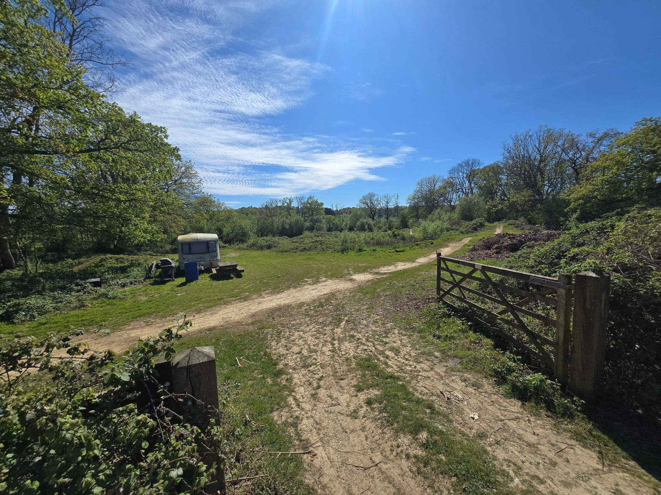
Supporting SEND, SEMH and Disengaged Young People Through Outdoor Education, Adventure and Personalised Support
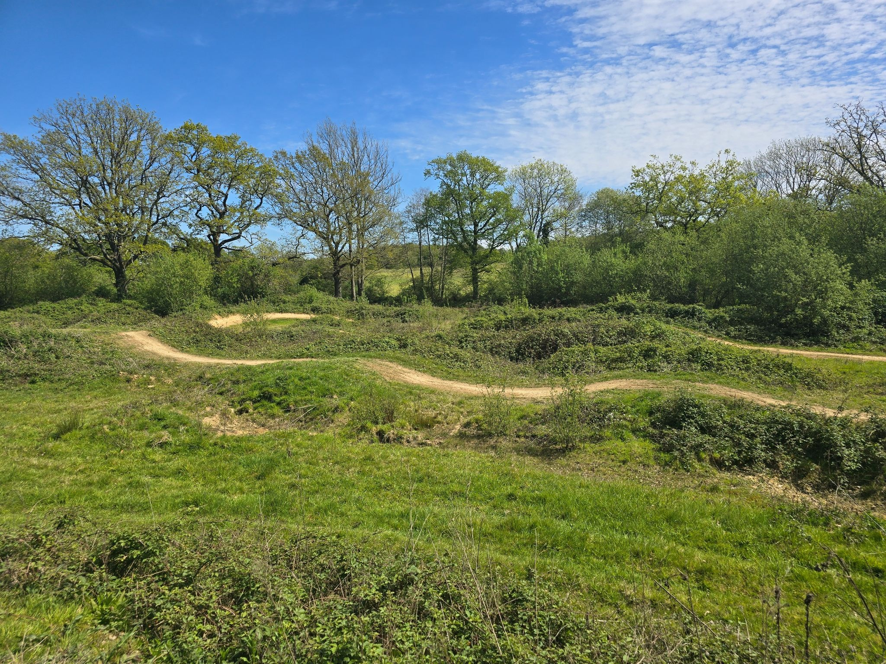
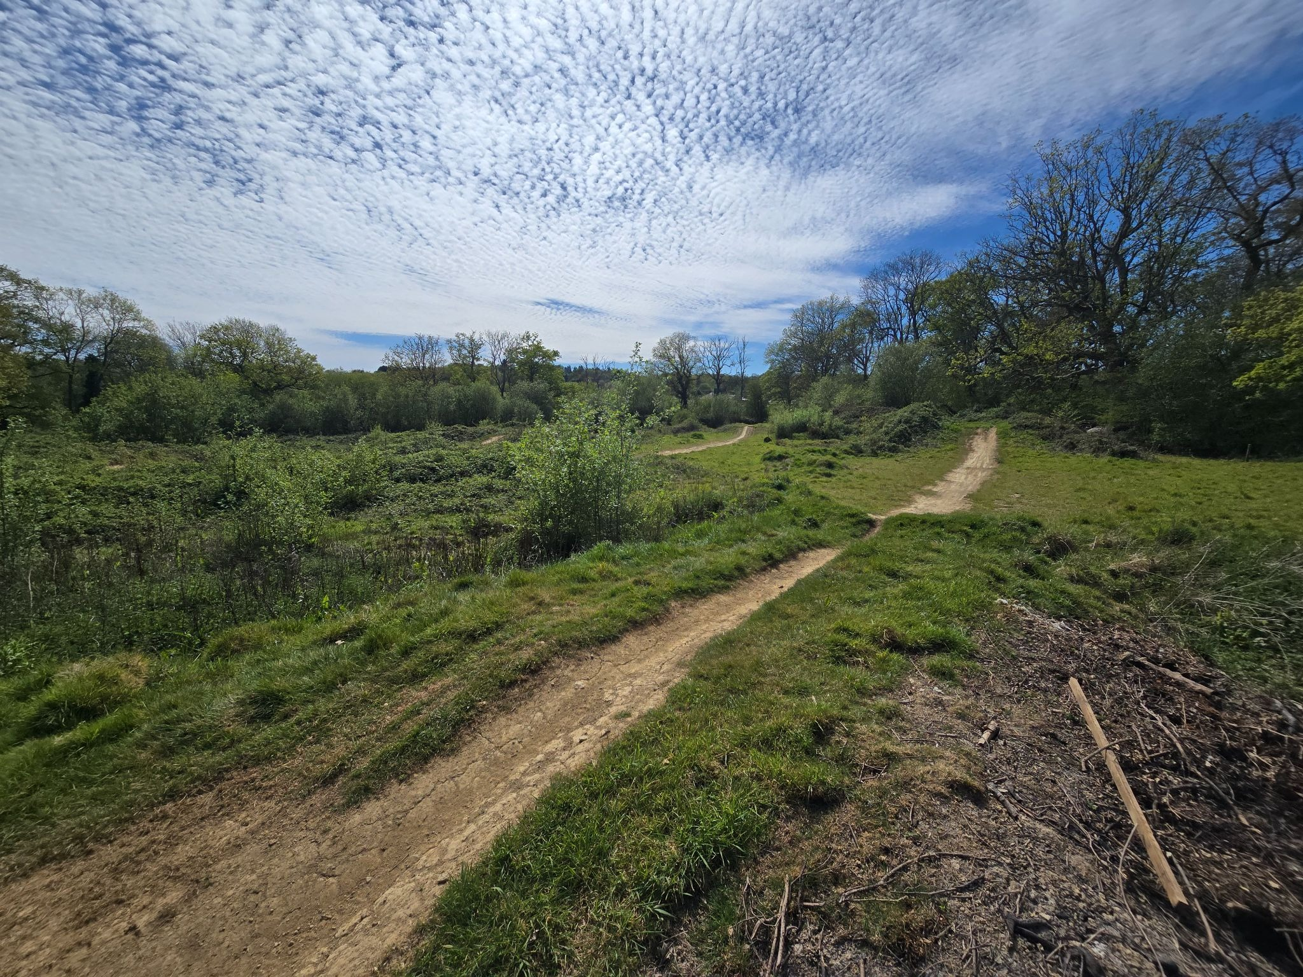

Our Philosophy
Most young people referred to alternative provision have experienced barriers to success within traditional educational settings. For some, school has become associated with anxiety, frustration or repeated experiences of failure. Others may struggle with emotional regulation, social communication, confidence or engagement with learning.
At Alt Outdoors, we believe meaningful progress happens when young people are provided with opportunities to experience success, develop positive relationships and discover strengths that may not be recognised within a traditional classroom environment.
Through carefully planned outdoor experiences, practical projects and personalised support, we create opportunities for young people to build confidence, resilience, independence and a renewed belief in their own abilities.

About Alt Outdoors
Alt Outdoors is led by Wilfy Gladwin-Nelson, a qualified teacher with over ten years of experience across mainstream and specialist education settings.
His experience includes roles as Pastoral Lead, Head of Outdoor Education, Teacher of Physical Education and Design Technology, and working within specialist SEND schools supporting young people with a wide range of additional needs.
This combination of teaching, pastoral, SEND and outdoor education experience ensures that activities are not simply recreational experiences but are intentionally designed to support educational, social, emotional and developmental outcomes.

Who We Support
Alt Outdoors supports young people who may experience SEND, Autism Spectrum Condition, ADHD, SEMH needs, anxiety, Emotionally Based School Avoidance (EBSA), low confidence, social communication difficulties, difficulties engaging with education and preparation for adulthood needs.
Provision is personalised to the individual and designed to build upon strengths while supporting areas of need identified by schools, families and professionals.

Why Outdoor Learning Works
Outdoor learning provides opportunities for young people to engage with education in a different way. Natural environments can reduce stress and anxiety, physical activity supports wellbeing, and practical learning often enables success for young people who struggle in more traditional academic settings.
Research from organisations including Natural England, NHS England, Sport England, the Education Endowment Foundation and the Institute for Outdoor Learning highlights the positive impact outdoor experiences can have on wellbeing, engagement, confidence and personal development.
At Alt Outdoors, outdoor learning is not viewed as an activity in itself; it is a vehicle through which meaningful outcomes can be achieved.

Mountain Biking as a Tool for Development
Mountain biking is one of the most powerful tools used within Alt Outdoors. Participants experience visible progression as they develop new skills, overcome challenges and gain confidence in their own abilities.
Young people learn to persevere when tasks feel difficult, assess and manage risk, take responsibility for equipment, improve physical fitness and experience achievement through effort and persistence.
For many young people, progression on a bike provides a tangible sense of success that can transfer into other areas of life and learning.

Bushcraft and Woodland Skills
Bushcraft activities provide immediate and rewarding opportunities for achievement. Whether learning to light a fire, safely use tools, prepare food outdoors or complete a woodland project, participants are encouraged to develop responsibility, patience and problem-solving skills.
Many young people who struggle to experience success within academic environments discover strengths through practical outdoor activities. Bushcraft supports confidence, resilience, concentration, executive functioning and risk awareness while providing meaningful and memorable experiences.

Practical Project Learning
As a qualified Design Technology teacher, Wilfy incorporates practical project-based learning throughout the provision.
Activities may include woodland construction projects, habitat creation, bug hotels, environmental projects, site improvement tasks and design-and-build activities.
These projects encourage planning, creativity, problem-solving and pride in achievement while providing opportunities to develop practical skills that can support future education, training and employment pathways.

Community Engagement & Preparation for Adulthood
Preparing young people for life beyond school is an important part of the Alt Outdoors approach.
Community visits and real-world learning opportunities help young people develop confidence in public settings, communication skills, independence and decision-making abilities.
Experiences may include shopping, journey planning, community participation, budgeting activities and supported access to local facilities, helping young people build confidence and independence for adulthood.

The Outcomes We Aim to Achieve
Alt Outdoors is designed to support progress across a range of areas including emotional regulation, confidence, resilience, engagement with learning, social communication, independence, physical wellbeing and re-engagement with education.
Whilst every young person is different, provision is intentionally designed to create opportunities for meaningful progress that can be recognised by schools, families and the young people themselves.

Measuring Progress
As a newly established provision, Alt Outdoors is committed to robust outcome monitoring from the outset.
Progress may be evidenced through attendance data, engagement records, observations, student voice, parent feedback, school feedback, participation levels and progress towards agreed targets or EHCP outcomes.
Where appropriate, schools may receive attendance summaries, progress reviews, engagement reports and end-of-placement feedback.

What Makes Alt Outdoors Different
Alt Outdoors combines Qualified Teacher Status, specialist SEND experience, pastoral leadership, outdoor education expertise and practical learning opportunities within a highly personalised small-group environment.
Rather than delivering activities for their own sake, every experience is designed with developmental outcomes in mind. Young people are supported by a practitioner who understands education, behaviour, SEND, outdoor learning and the importance of building positive relationships.
This unique combination enables Alt Outdoors to provide meaningful, outcome-focused provision tailored to the individual needs of each young person.

Commitment to Impact
As a newly established provision, Alt Outdoors is committed to embedding robust outcome monitoring and evaluation processes from the outset. Our aim is to provide schools, families and commissioners with clear evidence of progress while ensuring every young person receives a personalised programme designed to support meaningful educational, social and emotional development.

